**⇒ Mandatory Hands-On**

**Exercise 1: Setting Up JUnit**

junitdemo/pom.xml

<project xmlns="http://maven.apache.org/POM/4.0.0" xmlns:xsi="http://www.w3.org/2001/XMLSchema-instance" xsi:schemaLocation="http://maven.apache.org/POM/4.0.0 http://maven.apache.org/xsd/maven-4.0.0.xsd">

<modelVersion>4.0.0</modelVersion>

<groupId>com.example</groupId>

<artifactId>junitdemo</artifactId>

<version>default</version>

<dependencies>

<dependency>

<groupId>junit</groupId>

<artifactId>junit</artifactId>

<version>4.13.2</version>

<scope>test</scope>

</dependency>

</dependencies>

</project>

src/main/java/junitdemo/Calculator.java

package junitdemo;

public class Calculator {

public int add(int a, int b) {

return a + b;

}

public int multiply(int a, int b) {

return a * b;

}

}

src/test/java/junitdemo/CalculatorTest.java

package junitdemo;

import static org.junit.Assert.*;

import org.junit.Test;

public class CalculatorTest {

*@Test*

public void testAdd() {

Calculator calc = new Calculator();

int result = calc.add(5, 3);

*assertEquals*(8, result); // 5 + 3 = 8

}

*@Test*

public void testMultiply() {

Calculator calc = new Calculator();

int result = calc.multiply(4, 2);

*assertEquals*(8, result); // 4 * 2 = 8

}

}

**Result:**

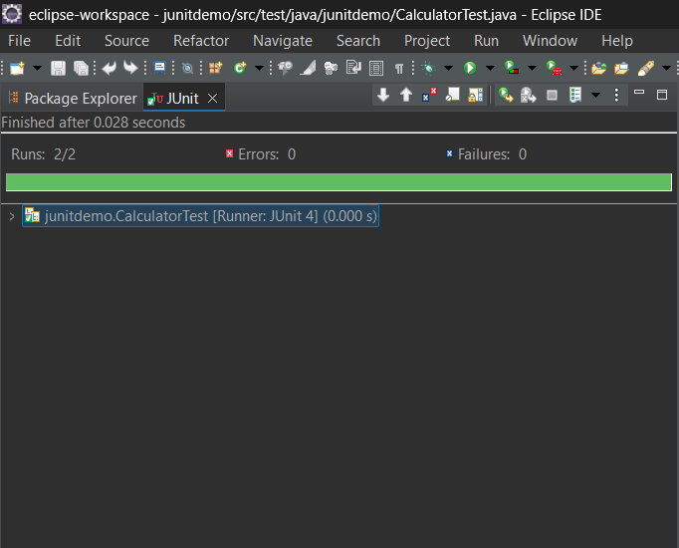

**Exercise 3: Assertions in JUnit**

src/test/java/junitdemo/AssertionsTest.java

package junitdemo;

import static org.junit.Assert.*;

import org.junit.Test;

public class AssertionsTest {

*@Test*

public void testAssertions() {

// Assert equals

*assertEquals*(5, 2 + 3);

// Assert true

*assertTrue*(5 > 3);

// Assert false

*assertFalse*(5 < 3);

// Assert null

*assertNull*(null);

// Assert not null

*assertNotNull*(new Object());

System.out.println("All assertions passed!");

}

}

**Result:**

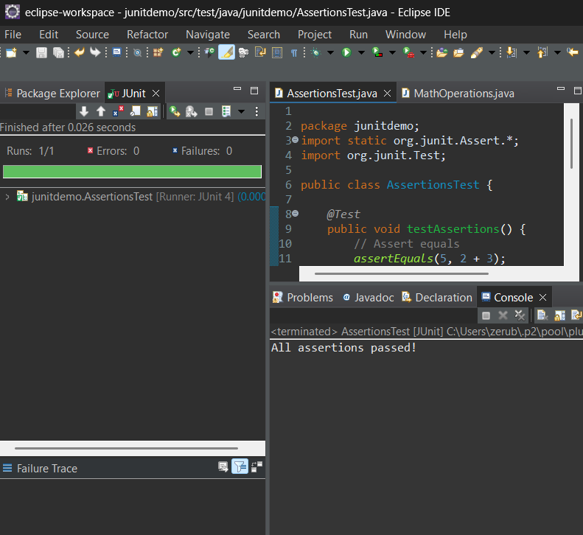

**Exercise 4: Arrange-Act-Assert (AAA) Pattern, Test Fixtures, Setup and Teardown Methods in JUnit**

src/main/java/junitdemo/MathOperations.java

**package junitdemo;**

**public class MathOperations {**

**public int add(int a, int b) {**

**return a + b;**

**}**

**public int divide(int a, int b) {**

**if (b == 0) throw new IllegalArgumentException("Cannot divide by zero");**

**return a / b;**

**}**

**}**

src/test/java/junitdemo/MathOperationsTest.java

**package junitdemo;**

**import static org.junit.Assert.*;**

**import org.junit.Before;**

**import org.junit.After;**

**import org.junit.Test;**

**public class MathOperationsTest {**

**private MathOperations math;**

***@Before***

**public void setUp() {**

**System.*out*.println("Setting up...");**

**math = new MathOperations();**

**}**

***@After***

**public void tearDown() {**

**System.*out*.println("Cleaning up...");**

**math = null;**

**}**

***@Test***

**public void testAddition() {**

**int result = math.add(10, 5);**

***assertEquals*(15, result);**

**}**

***@Test***

**public void testDivision() {**

**int result = math.divide(20, 4);**

***assertEquals*(5, result);**

**}**

***@Test*(expected = IllegalArgumentException.class)**

**public void testDivisionByZero() {**

**math.divide(10, 0);**

**}**

**}**

**Result:**

